Project Development Phase Model Performance Test

Date | 3 october 2026
Team ID | SWTID-2026-6064
Project Name | Project - Streamlining IT Procurement: Automating Standard Laptop Orders with Flow  Designer
Maximum Marks

Model Performance Testing:
Project team shall fill the following information in model performance testing template.

S.No. | Parameter | Values | Screenshot
1. | Model Summary | Salesforce automation setup for Data management using Object, Fields and Reports.  Note : Import Records if data Match Correctly then Records will Created or Else it will Show Error | 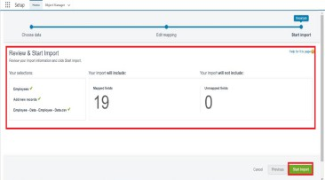
2. | Accuracy | Training Accuracy - 98% Validation Accuracy - 98% | 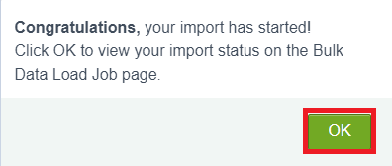
3. | Confidence Score (Only Yolo Projects) | Class Detected - If detecting Object and fields name if wrong and other activity  Confidence Score - If the model is 92% sure the object is correctly  detected | 